|  |
| --- |
|  |
| **CHAPTER ONE** |

**INTRODUCTION**

**CHAPTER 1**

**Introduction**

* 1. **Fundamentals of the project**

Library is regarded as the brain of any institute. Library is place where all kind of books are available. Many institutes understand the importance of the library to the growth of the institute and their users. Library project system that offers many flexible features. Library management is entering the records of new book and retrieving the details of book available in the library. It gives the all detailed information about students, staff and books. It shows popular book among the students. It will provide book lost in library. The purpose of building this app is to make a well distribution of books in the library system. It arranges all the books in department wise. Then one can search any book by department. A client can keep a book for a limited time. Each day of delay, requires fine. The app sends notification to the client to remainder about the validation and also counts the fine with each day of release the book return to library. Only basic knowledge of computers is required for operation of Library Management. It has user friendly application interface. Library Management has predefined reports. It calculates automatic fine fees. User can search for books online.

Library Management System is a sub-discipline of industrial management that focuses on specific faced by libraries and library management professionals. Library Management encompasses normal managerial tasks, as well as intellectual freedom and fundraising responsibilities.

* 1. **Background and Present State**

In our existing system all the transactions of books are done manually. So, taking more time for a transaction like borrowing a book or returning a book and also for searching a books. Another major disadvantage is that to preparing the list of books borrowed and the available books in the library will take more time, currently it is doing as a one day process for verifying all records. Library Management System is an application refers to other library system and it is suitable to use by small and medium size library. It is use by librarian and library admin to manage the library by a computerized system. The system was developed and designed to help librarian record every book transaction so that the problem such as file missing or record missing will not happened again. In the present existing system, library system is manual and lengthy process. There are many cases where the file or record missing and wastages time. This project has many features which are generally not available in normal library management systems like facility of user login and a facility of admin login. The user is able to generate different kinds of books, issue and return reports. “Library Management System” is designed to help users maintain and organize library.

Background system is unable to analyze past data and it is difficult to handle data accurately mainly security problem. But in present there are some desktop based, android based system so that, the system is spontaneous. Proposed system is an automated library management system.

* 1. **Motivation and Aims**
* This system is developed and designed to help librarian record every book transaction so that the problem such as file missing or record missing will not happened again.
* In present state library system is manual. It is lengthy process and wastages our many valuable time. If the system is update by android based spontaneous system the harassment is also removing.
* Online book issue. Improvement in control and performance.
* Then library client easily searching books in department wise and overcome existing problems occurring in maintenance of books information.
  1. **Objectives and Specific Aims**

The project objectives and aims that will be achieved after completion of the system were carried out in this sub chapter. The success of the system will be evaluated through this sub chapter.

* To eliminate the paper-work in library
* To record every transaction in computerized system so that problem such as record or file missing won’t happen again
* To complete the systems according to project schedule
* To produce technical report that documents the phases, tasks and deliverables in the project
* To convert manual to spontaneous
* To better progress of library
* To create student login page where student can find books issued by him or her and date of return
* To count the fine with each day of release the book return to library

The aim is to accomplish successful implementation of application, approved by the authority.

* 1. **Organization of the Project**

The dissertation is organized as follows:

* **Chapter 1 Introduction.** In this chapter an introduction to our system has been given.
* **Chapter 2 Literature Review.** This chapter shows the state of the art work in the field of our system.
* **Chapter 3 Methodology.** We present our proposed technique to our system in this chapter.
* **Chapter 4 Experiments Analysis.** In this chapter, it has been shown the effectiveness and efficiency of our proposed method.
* **Chapter 5 Conclusion and Recommendations.** Finally, this chapter concludes the dissertation indicating the limitations and future works.

Introduction

Literature Review

Methodology and System Requirements

Project Description and Analysais of Results

Conclusions and Recommendation

**Figure 1.1**: Project Structure

The first chapter introduces the project background, fundamentals of the project, objectives of the project, organization of the project and Structure of the project.

The second chapter discusses the existing system analysis, advantages of the current system, limitation of the Current System.

The third chapter covers a brief description of methodology, hardware specification, software specification, external interface, user interface, functional requirements, reservation, performance requirements.

The fourth chapter introduces project description and analysis of results in which the screenshot of different modules and their description will be explained and the result discussion will be exemplified.

The chapter six will be described the conclusion and recommendation for future plan of this project.

|  |
| --- |
|  |
| **CHAPTER TWO** |

**LITERATURE REVIEW**

**CHAPTER 2**

**Literature Review**

The library management system is designed for any library to replace their existing manual system. The new system to control the books information, clients information, search by department, borrow books. There are some related projects such as book shopping management, hostel management, bus ticket reservation. Library currently used a manual system for the management and maintenance of critical information. The current system requires numerous technologies. Often information is incomplete or does not follow management standards. Background system is manual so the new system to solve this problem. The previous system is hard and lengthy process. I think this system wastages our time.

The purpose of building this app is to make a well distribution of books in the library system. By this system we can borrow books, read more books and learn knowledge. This app arranges all the books in department wise. It is helpful for librarian and librarian admin. A client can keep a book for a limited time. Each day of delay requires fine. The previous system does not use Barcode. By using Barcode we can detect registered books for limited time. To eliminate the paper work in library. Background system is unable to record and analyze past data. It is difficult to handle data accurately so we make a automatic system in library.

|  |
| --- |
|  |
| **CHAPTER THREE** |

**PROPOSED METHODOLOGY**

**CHAPTER 3**

**Proposed Methodology**

**3.1 Outline of Methodology Design**

Library management system is a project which developing a computerized system to maintain all the daily work of library. This project will be developed by using android studio (java, xml), SQLite. The library management system will be developed in android platform using database. To develop this system firstly, we collect the requirements for the library system and then we analyzed it. This system contains list of all the books. Using this system user can issue book to the library member, maintain their records, and can checks how many books are issued and how many books are available in the library. This system provides separate interface and login for librarian, students and departments. Librarian can modify database. Using the library management system, user can also maintain the late fine of library member who return the issued book after the due date.

In this proposed system, we assume that each member will be having email id and password for login which can be used for the library book issue, search books, payment due to delay time etc. whenever library member wish to take a book, the book issued by the library authority will be check both the book details as well as the student details and store it in library database. In case of retrieval of book much of human invention can be eliminated.

Users can search for books and renewal books. In the proposed system, we assume that each member will be having a identity card which can be used for the library book issue, fine payment etc. Whenever library member wish to take a book, the book issued by the library authority will be check both the book details as well as the student details and store it in library database. They can view the issue and return dates of any book and due they have to pay.

Once there is a bug founded, it will be solve immediately before the system is launched to ensure the system launched is bug free.

* Hardware
* Processor: Intel(R) core™ i3-4010UCPU@1.70GHZ
* Ram:4.00 GB
* Android phone
* Software
* Android studio
* Database: SQLite
* Java language

**3.2 Module Description**

* Admin Module

This module contains various facilities like student validation, student registration, book addition.

ADMIN

BOOK ADDITION

STUDENT REGISTRATION

STUDENT VALIDATION

**Figure 4.1:** Admin Module

* Student Module

This module contains various facilities like student registration, student login, online book borrow.

STUDENT

ONLINE BOOK BORROW

STUDENT LOGIN

STUDENT REGISTRATION

USERNAME AND PASSWORD

**Figure 3.2**: Student Module

|  |
| --- |
|  |
| **CHAPTER FOUR** |

**EXPERIMENTAL ANALYSIS**

**CHAPTER 4**

**Experimental Analysis**

**4.1 Login page**

At first user have to login to enter the system. They are required to key in the user id and password before they are allows entering the system

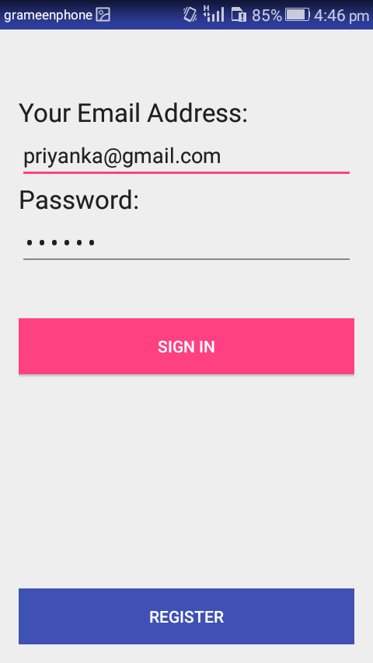

**Figure 4.1**: Login page

**4.2** **Register New Books**

This feature can be performing by all users to register new book to the library.

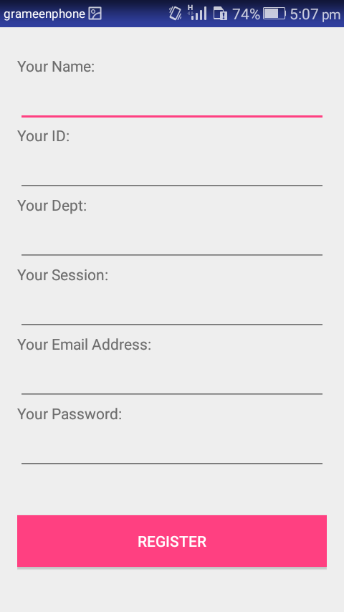

**Figure 4.2**: Registration page

**4.3 List of Books**

A book is a series of pages. This is a list of books in a library. User can get all available books in library.

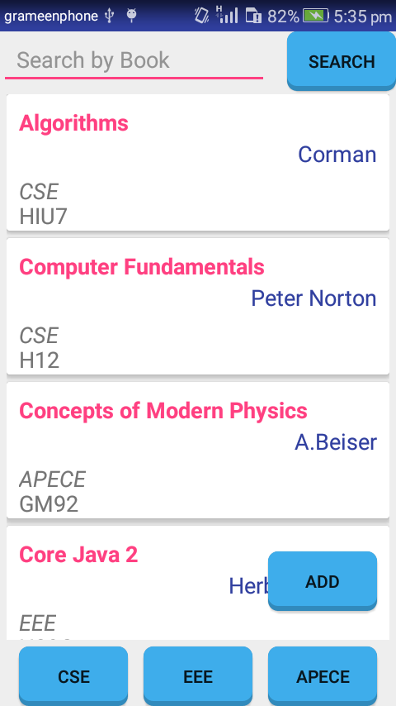

**Figure 4.3**: List of books

**4.4 Search Book**

This feature is found at book maintenance part. User can search book based on book title of first name.

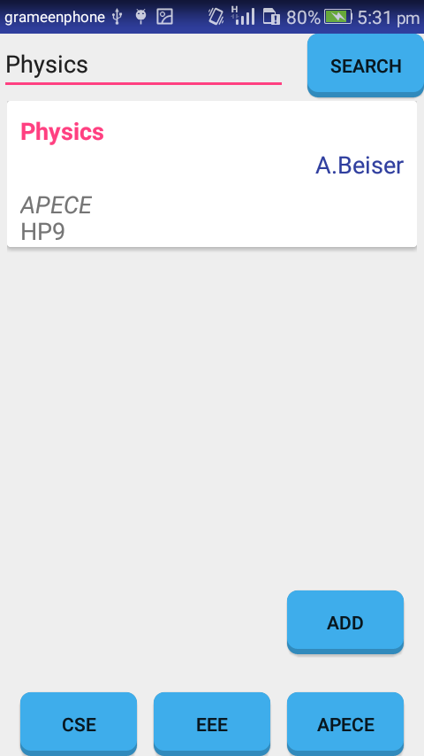

**Figure 4.4:** Search books

**4.5 Add Books**

To add new books in library based on book name, author, dept and shelf no. in the following figure:

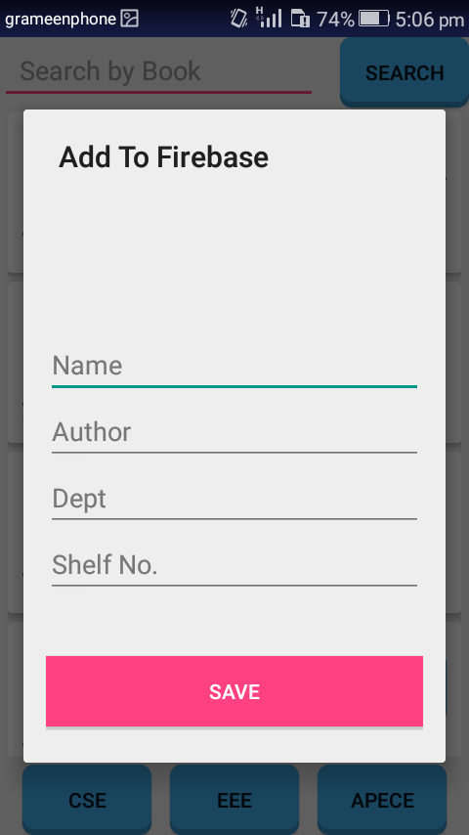

**Figure 4.5**: Add new book

**4.6 Borrow books**

When user want to borrow books, click in the following figure:

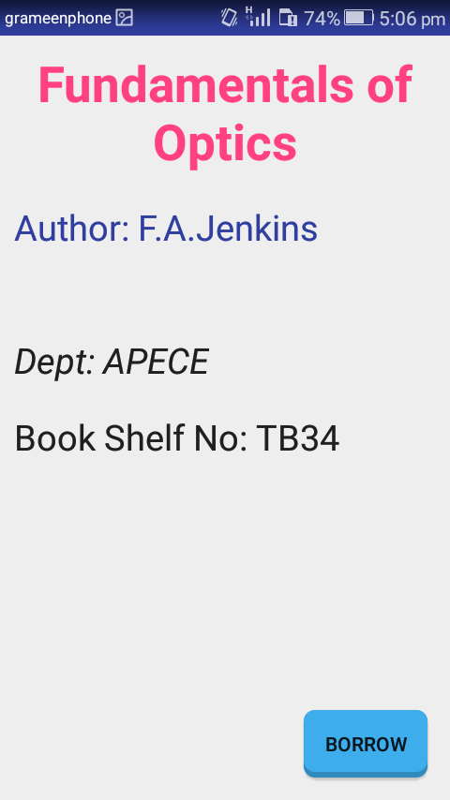

**Figure 4.6**: Borrow books

**4.7 Main view**

The main view of this project is in the following figure,

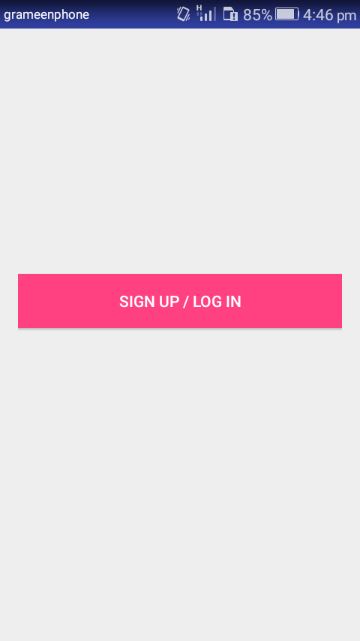

**Figure 4.7:** Main view

|  |
| --- |
|  |
| **CHAPTER FIVE** |

**CONCLUSION AND FUTURE WORK**

**CHAPTER 5**

**Conclusion and Future Work**

In this chapter we summarize the project works presented in this dissertation and make final concluding remarks with few directions for future works.

**5.1 Conclusion**

The Library Management System was developed to replace the manual process of arranging books and other information. The current system keep information accurately but the previous system does not keep information correctly. It will digitalized the library system as well as it wil make easier the working procedures. I hope my project “ Online Library Management System” will be very helpful for a library. It will provide books information, clients,adding new books, borrow and return books for the time. It is used by librarian to manage the library using a computerized system where users can records various transactions like issue of books, return of books, addition of new books, addition of new students etc. Because of the new library system and to develop this system and, I hope you will allow me to do this project.

**5.2 Future work**

In future we make this project more secure and more efficient. After analyzing the results of the developed systems, the following issues are still open which can be taken up as future enhancements. Android phones are widely used everywhere, it is obvious that application these offer simple solutions to do our daily activities. This android application can be used for all students, members.In future I will try my best to add notification system.

.

**References**

1. C. J. M. L. M. Eliassen, R. Saetre, and B. Gamback,” real time information in an intelligent smartphone application,” in Gesellschaft fir Informatik eV(GI) publishes this series in order to make available to a broad public recent findings in informatics (ie computer science and information systems), to document conferences that are organized in co-operation with GI and to publish the annual GI Award dissertion. Citeseer, 2012, p. 48.
2. Y. Sardey, P. Deshmukh, P. Mandilk, S. Shelar, and M. Nerkar,”A mobile application for library management system,”Institute of Information Technology, Department of Computer Science, Pune, India,2014.

[3] M.-C. Chen, J.-L. Chen, and T.-W. Chang, “Android/osgi-based vehicular network

management system," *Computer Communications*, vol. 34, no.2, pp.169-183, 2011.

[4] G. Lee and J. Yim, “Design of an android library system provider," *Life*

*Science Journal*, vol. 11, no. 7, pp. 619{625, 2014.

[5] M.-C. Chen, J.-L. Chen, and T.-W. Chang, “Android/osgi-based vehicular net-

work management system," *Computer Communications*, vol. 34, no. 2, pp. 169-

183, 2011.

|  |
| --- |
|  |
| **CHAPTER SIX** |

**CONCLUSION AND FUTURE WORK**